Lab 4. Database Programming

**4.1 Write a PL/SQL block to find the maximum salary of the staff in the given department. Note: Department code should be passed as parameter to the cursor.**

**Input:**

DECLARE

CURSOR C_info IS

SELECT max(Staff_Sal) FROM Staff_Master WHERE Dept_Code = &Dept_Code;

Max_sal Staff_Master.Staff_Sal%TYPE;

BEGIN

OPEN C_Info;

FETCH C_Info INTO Max_Sal;

IF C_Info%FOUND THEN

DBMS_OUTPUT.PUT_LINE('Maximum Salary is:'||Max_Sal);

END IF;

CLOSE C_Info;

END;

/

**OUTPUT:**

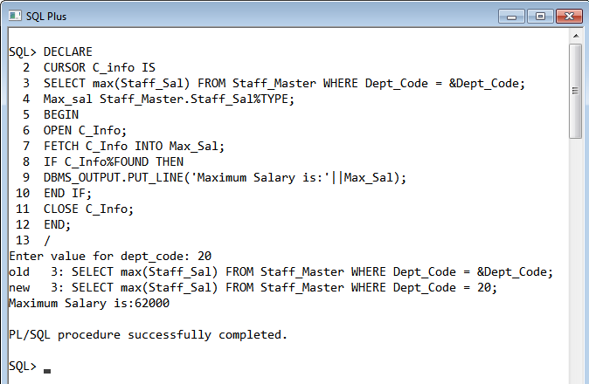

**4.2. Write a function to compute age. The function should accept a date and return age in**

**years.**

**INPUT:**

CREATE OR REPLACE FUNCTION Age(Birthdate in Date)

RETURN NUMBER IS

age_in_years Number(20);

BEGIN

age_in_years:=ROUND(months_between(SYSDATE,Birthdate)/12);

RETURN age_in_years;

EXCEPTION

WHEN OTHERS THEN

RETURN 0;

END;

/

SELECT Staff_Code,Staff_Name,Age(Staff_DOB) FROM Staff_Master;

**OUTPUT:**

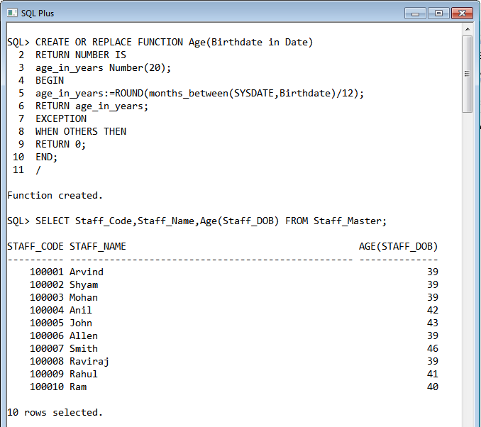

**4.3. Write a procedure that accept staff code and update staff name to Upper case. If the**

**staff name is null raise a user defined exception.**

**INPUT:**

CREATE OR REPLACE PROCEDURE To_Upper(Staff_ID in NUMBER) IS

CURSOR C_Name IS

SELECT Staff_Code,Staff_Name FROM Staff_Master WHERE Staff_Code=Staff_ID;

var C_Name%ROWTYPE;

Name_Null EXCEPTION;

BEGIN

OPEN C_Name;

FETCH C_Name INTO var;

IF C_Name%FOUND THEN

IF var.Staff_Name IS NULL THEN

RAISE Name_Null;

ELSE

UPDATE Staff_Master SET Staff_Name=UPPER(var.Staff_Name) WHERE Staff_Code=var.Staff_Code;

END IF;

ELSE

DBMS_OUTPUT.PUT_LINE('No Record Found');

END IF;

COMMIT;

CLOSE C_Name;

EXCEPTION

WHEN Name_Null THEN

DBMS_OUTPUT.PUT_LINE('Name not found for the given Staff Name');

END;

/

BEGIN

To_Upper(100001);

END;

/

SELECT * FROM STAFF_MASTER WHERE STAFF_CODE=100001;

**OUTPUT:**

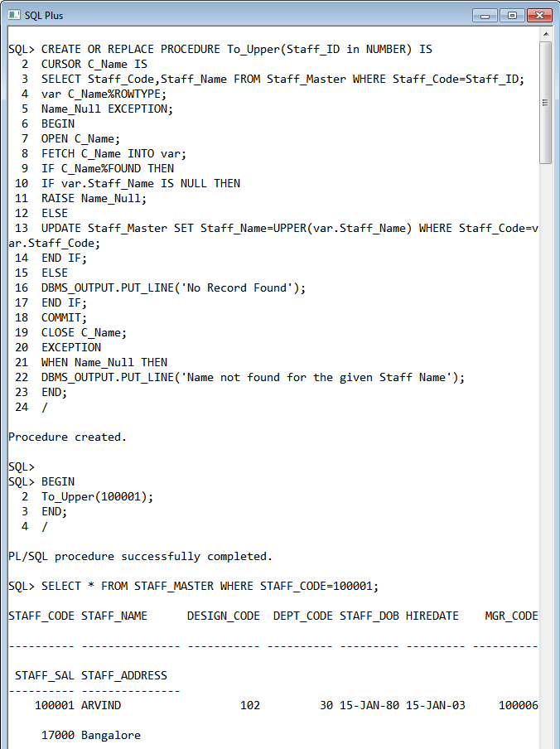

**4.4 Write a procedure to find the manager of a staff. Procedure should return the**

**following – Staff_Code, Staff_Name, Dept_Code and Manager Name.**

**INPUT:**

CREATE OR REPLACE PROCEDURE Find_Manager(Staff_ID in NUMBER) IS

CURSOR C_Name IS

SELECT s1.Staff_Code,s1.Staff_Name,s1.Dept_Code,s2.Staff_Name"Manager_Name"

FROM Staff_Master s1,Staff_Master s2 WHERE s2.Staff_Code=s1.MGR_Code and s1.Staff_Code=Staff_ID;

Code staff_Master.Staff_Code%TYPE;

Name Staff_Master.Staff_Name%TYPE;

Dept Staff_Master.Dept_Code%TYPE;

Manager Staff_Master.Staff_Name%TYPE;

BEGIN

OPEN C_Name;

DBMS_OUTPUT.PUT_LINE('Staff Code '||' Staff Name '||' Dept Code '||' Manager Name');

LOOP

FETCH C_Name INTO Code,Name,Dept,Manager;

EXIT WHEN C_Name%NOTFOUND;

IF C_Name%FOUND THEN

DBMS_OUTPUT.PUT_LINE(Code||' '||Name||' '||Code||' '||Manager);

END IF;

END LOOP;

COMMIT;

CLOSE C_Name;

END;

/

BEGIN

Find_Manager(100008);

END;

/

BEGIN

Find_Manager(100006);

END;

/

**OUTPUT:**

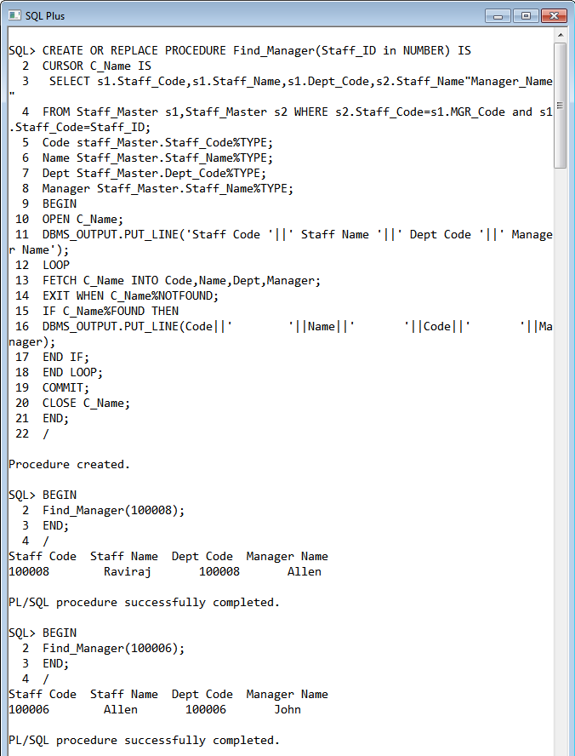

**4.5. Write a function to compute the following. Function should take Staff_Code and**

**return the cost to company.**

DA = 15% Salary, HRA= 20% of Salary, TA= 8% of Salary.

Special Allowance will be decided based on the service in the company.

< 1 Year Nil

>=1 Year< 2 Year 10% of Salary

>=2 Year< 4 Year 20% of Salary

>4 Year 30% of Salary

**INPUT:**

CREATE OR REPLACE FUNCTION CTC(Staff_ID in NUMBER)

RETURN number is

sal staff_master.staff_sal%type;

DOJ staff_master.hiredate%type;

ctc number(10);

DA number(10);

HRA number(10);

TA number(10);

Spl_Allow number(10);

exp number(10);

BEGIN

select staff_sal,hiredate INTO sal,DOJ FROM staff_master WHERE staff_code=Staff_ID;

DA:=sal*15/100;

HRA:=sal*20/100;

TA:=sal*8/100;

exp:=round((sysdate-DOJ)/365);

IF exp>=1 and exp<2 then

Spl_Allow:=sal*10/100;

ELSIF exp>=2 and exp<3 then

Spl_Allow:=sal*20/100;

ELSIF exp>4 then

Spl_Allow:=sal*30/100;

ELSE

Spl_Allow:=0;

END IF;

ctc:=DA+HRA+TA+Spl_Allow+sal;

RETURN ctc;

END;

/

**OUTPUT:**

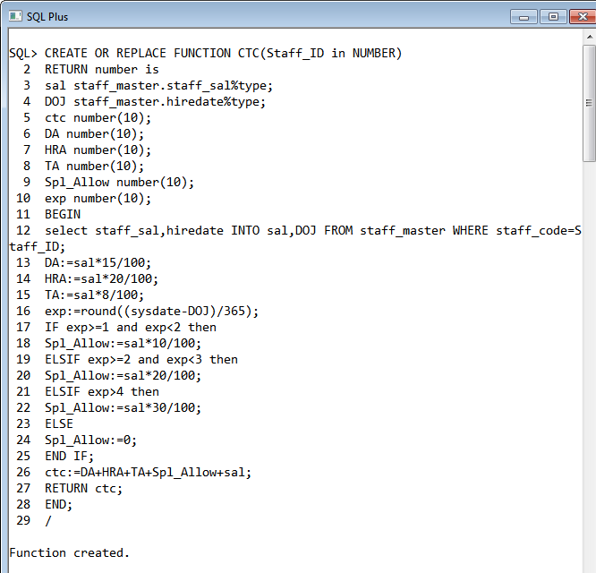

**4.6. Write a procedure that displays the following information of all staff**

**Staff_Name Department Name Designation Salary Status**

Note: - Status will be (Greater, Lesser or Equal) respective to average salary of their own

department. Display an error message Staff_Master table is empty if there is no matching

record.

**INPUT:**

CREATE OR REPLACE PROCEDURE Staff_Info IS

CURSOR C_Staff IS

SELECT s.Staff_Name,s.Dept_Code,d1.Dept_Name,d2.Design_Name,s.Staff_Sal

FROM Staff_Master s,Department_Master d1,Designation_Master d2

WHERE s.Dept_Code=d1.Dept_Code and s.Design_Code=d2.Design_Code;

var C_Staff%ROWTYPE;

Avrg Staff_Master.Staff_Sal%TYPE;

Status VARCHAR2(20);

counter NUMBER:=0;

BEGIN

OPEN C_Staff;

DBMS_OUTPUT.PUT_LINE('Staff Name '||' Department Name '||' Designation '||' Salary '||' Status');

DBMS_OUTPUT.PUT_LINE('------------------------------------------------------------------------------------------');

LOOP

FETCH C_Staff INTO var;

EXIT WHEN C_Staff%NOTFOUND;

IF C_Staff%FOUND THEN

counter:=counter+1;

SELECT Avg(Staff_Sal) INTO Avrg FROM Staff_Master WHERE Dept_Code=var.Dept_Code;

IF var.Staff_Sal > Avrg THEN

Status:='Greater';

ELSIF var.Staff_Sal < Avrg THEN

Status:='Lesser';

ELSE

Status:='Equal';

END IF;

DBMS_OUTPUT.PUT_LINE(var.Staff_Name||' '||var.Dept_Name||' '||var.Design_Name||' '||var.Staff_Sal||' '||Status);

END IF;

END LOOP;

IF counter=0 THEN

DBMS_OUTPUT.PUT_LINE('There is no matching Record.');

END IF;

COMMIT;

CLOSE C_Staff;

END;

/

BEGIN

Staff_Info;

END;

/

**OUTPUT:**

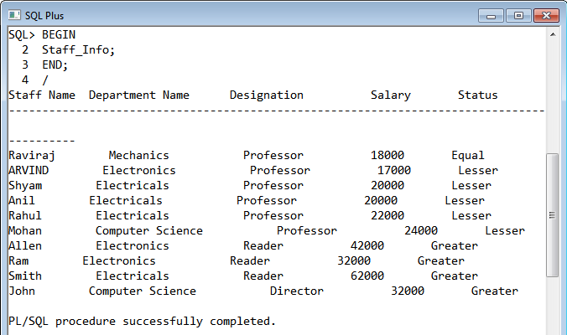

**4.7. Write a procedure that accept Staff_Code and update the salary and store the old**

**salary details in Staff_Master_Back (Staff_Master_Back has the same structure without**

**any constraint) table.**

Exp < 2 then no Update

Exp > 2 and < 5 then 20% of salary

Exp > 5 then 25% of salary

**INPUT:**

CREATE OR REPLACE PROCEDURE Update_Salary(Staff_ID NUMBER) IS

Exp NUMBER;

Increment NUMBER;

Salary NUMBER;

BEGIN

SELECT round(months_between(SYSDATE,HIREDATE)/12),Staff_Sal INTO Exp,Salary FROM Staff_Master WHERE STaff_Code=Staff_ID;

IF Exp < 2 THEN

Increment:=0;

ELSIF (Exp > 2 AND Exp < 5) THEN

Increment:=0.20*Salary;

ELSE

Increment:=0.25*Salary;

END IF;

INSERT INTO Staff_Master_Back

SELECT * FROM Staff_Master WHERE Staff_Code=Staff_ID;

UPDATE Staff_Master

SET STaff_Sal=Staff_Sal+Increment

WHERE Staff_Code = Staff_ID;

COMMIT;

EXCEPTION

WHEN NO_DATA_FOUND THEN

DBMS_OUTPUT.PUT_LINE('No Record Found');

END;

/

BEGIN

Update_Salary(100008);

END;

/

SELECT * FROM Staff_Master WHERE Staff_Code=100008;

**OUTPUT:**

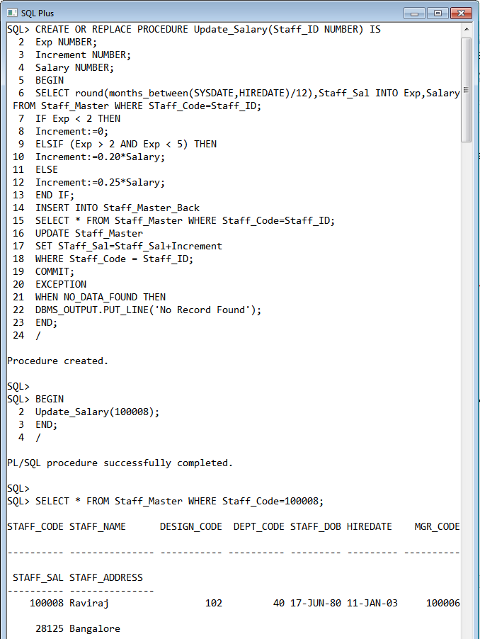

**4.8. Create a procedure that accepts the book code as parameter from the user. Display**

**the details of the students/staff that have borrowed that book and has not returned the**

**same. The following details should be displayed Student/Staff Code Student/Staff Name Issue Date Designation Expected Ret_Date**

**INPUT:**

CREATE OR REPLACE PROCEDURE Pending_Books(Book_ID NUMBER) IS

CURSOR C_Stu_Books IS

SELECT s1.Student_Code,s1.Student_Name,b.Book_Issue_Date,b.Book_Expected_Return_Date

FROM Student_Master s1,Book_Transactions b

WHERE s1.Student_Code=b.Student_Code AND b.Book_Code=Book_ID;

var1 C_Stu_Books%ROWTYPE;

CURSOR C_Sta_Books IS

SELECT s2.Staff_Code,s2.Staff_Name,d.Design_Name,b.Book_Issue_Date,b.Book_Expected_Return_Date

FROM Staff_Master s2,Designation_master d,Book_Transactions b

WHERE s2.Staff_Code=b.Staff_Code AND s2.Design_code=d.Design_Code AND b.Book_Code=Book_ID;

var2 C_Sta_Books%ROWTYPE;

BEGIN

DBMS_OUTPUT.PUT_LINE('Student/Staff Code'||' '||'Student/Staff Name'||' '||'Issue Date'||' '||'Designation'||' '||'Expected Ret_Date');

OPEN C_Stu_Books;

LOOP

FETCH C_Stu_Books INTO var1;

EXIT WHEN C_Stu_Books%NOTFOUND;

IF C_Stu_Books%FOUND THEN

DBMS_OUTPUT.PUT_LINE(var1.Student_Code||' '||var1.Student_Name||' '||var1.Book_Issue_Date||' '||'NA'||' '||var1.Book_Expected_Return_date);

END IF;

END LOOP;

CLOSE C_Stu_Books;

OPEN C_Sta_Books;

LOOP

FETCH C_Sta_Books INTO var2;

EXIT WHEN C_Sta_Books%NOTFOUND;

IF C_Sta_Books%FOUND THEN

DBMS_OUTPUT.PUT_LINE(var2.Staff_Code||' '||var2.Staff_Name||' '||var2.Book_Issue_Date||' '||var2.Design_Name||' '||var2.Book_Expected_Return_date);

END IF;

END LOOP;

CLOSE C_Sta_Books;

COMMIT;

EXCEPTION

WHEN NO_DATA_FOUND THEN

DBMS_OUTPUT.PUT_LINE('No Record Found');

END;

/

BEGIN

Pending_Books(10000005);

END;

/

**OUTPUT:**

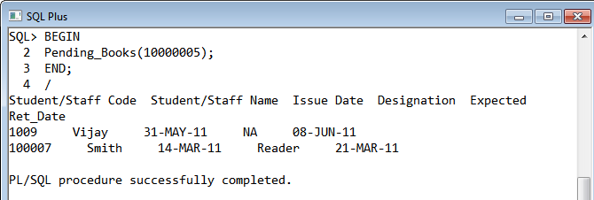

**4.9. Write a package which will contain a procedure and a function.**

**Function: This function will return years of experience for a staff. This function will take**

**the hiredate of the staff as an input parameter. The output will be rounded to the nearest**

**year (1.4 year will be considered as 1 year and 1.5 year will be considered as 2 year).**

**Procedure: Capture the value returned by the above function to calculate the additional**

**allowance for the staff based on the experience.**

**Additional Allowance = Year of experience x 3000**

**Calculate the additional allowance and store Staff_Code, Date of Joining, and Experience**

**in years and additional allowance in Staff_Allowance table.**

**INPUT:**

CREATE TABLE STAFF_ALLOWANCE (

STAFF_CODE NUMBER(20),

HIREDATE DATE,

EXPR NUMBER(10),

ALLOWANCE NUMBER(10,2));

CREATE OR REPLACE PACKAGE staff_package

AS

FUNCTION EXPERIENCE(V_HIREDATE IN STAFF_MASTER.HIREDATE%TYPE) RETURN NUMBER;

PROCEDURE ALLOWANCE(S_CODE IN NUMBER);

END;

/

CREATE OR REPLACE PACKAGE BODY staff_package

AS

FUNCTION EXPERIENCE(V_HIREDATE IN STAFF_MASTER.HIREDATE%TYPE)

RETURN NUMBER

IS

c_expr NUMBER;

BEGIN

c_expr := ROUND(MONTHS_BETWEEN(SYSDATE,V_HIREDATE)/12,0);

RETURN c_expr;

END EXPERIENCE;

PROCEDURE ALLOWANCE(S_CODE IN NUMBER)

IS

C_EXPR NUMBER;

ADDITIONAL_ALLOWANCE NUMBER;

V_HIREDATE STAFF_MASTER.HIREDATE%TYPE;

BEGIN

SELECT HIREDATE

INTO V_HIREDATE

FROM STAFF_MASTER

WHERE STAFF_CODE = S_CODE;

C_EXPR := staff_package.EXPERIENCE(V_HIREDATE);

DBMS_OUTPUT.PUT_LINE(C_EXPR);

ADDITIONAL_ALLOWANCE := C_EXPR * 3000;

INSERT INTO STAFF_ALLOWANCE VALUES(S_CODE, V_HIREDATE, C_EXPR, ADDITIONAL_ALLOWANCE);

DBMS_OUTPUT.PUT_LINE(ADDITIONAL_ALLOWANCE);

END ALLOWANCE;

END staff_package;

/

DECLARE

S_CODE STAFF_MASTER.STAFF_CODE%TYPE;

BEGIN

S_CODE:=&staff_code;

staff_package.ALLOWANCE(S_CODE);

Dbms_output.put_line('DONE SUCCESSFULLY ');

END;

/

**OUTPUT:**

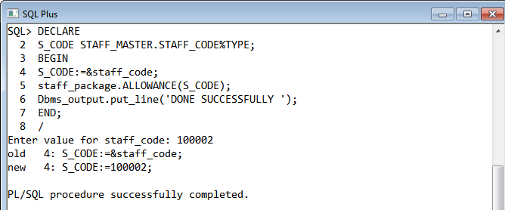

**4.10. Write a procedure to insert details into Book_Transaction table. Procedure should**

**accept the book code and staff/student code. Date of issue is current date and the**

**expected return date should be 10 days from the current date. If the expected return date**

**falls on Saturday or Sunday, then it should be the next working day.**

**INPUT:**

CREATE OR REPLACE PROCEDURE Issue_Books(Book_ID NUMBER,Stu_Sta_ID NUMBER) IS

Issue_Date DATE;

Expect_Return_date DATE;

BEGIN

Issue_Date:=SYSDATE;

IF TO_CHAR(Issue_Date+10,'dy')='sat' THEN

Expect_Return_Date:=Issue_Date+12;

ELsIF TO_CHAR(Issue_Date+10,'dy')='sun' THEN

Expect_Return_Date:=Issue_Date+11;

ELSE

Expect_Return_Date:=Issue_Date+10;

END IF;

IF LENGTH(TO_CHAR(Stu_Sta_ID))=4 THEN

INSERT INTO Book_Transactions(Book_Code,Student_Code,Book_Issue_Date,Book_Expected_Return_Date)

VALUES(Book_ID,Stu_Sta_ID,Issue_Date,Expect_Return_Date);

ELSIF LENGTH(TO_CHAR(Stu_Sta_ID))=6 THEN

INSERT INTO Book_Transactions(Book_Code,Staff_Code,Book_Issue_Date,Book_Expected_Return_Date)

VALUES(Book_ID,Stu_Sta_ID,Issue_Date,Expect_Return_Date);

ELSE

DBMS_OUTPUT.PUT_LINE('INVALID Student or Staff ID');

END IF;

COMMIT;

END;

/

BEGIN

Issue_Books(10000006,1012);

END;

/

SELECT * FROM Book_Transactions;

**OUTPUT:**

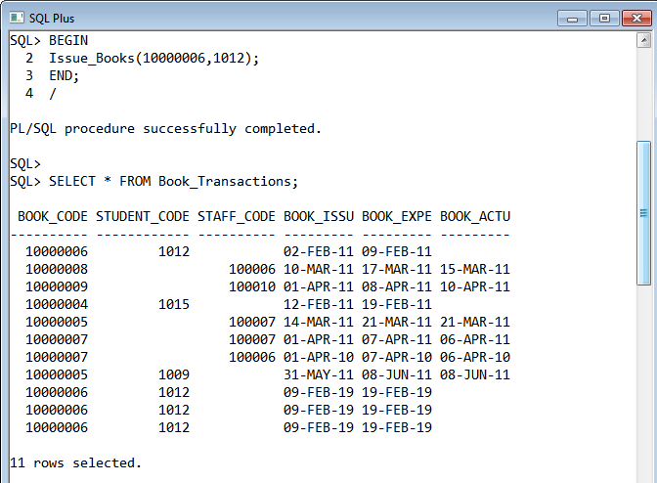

**4.11: Write a function named ‘get_total_records’, to pass the table name as a parameter,**

**and get back the number of records that are contained in the table. Test your function**

**with multiple tables.**

**INPUT:**

CREATE or REPLACE FUNCTION Get_Total_Records(Table_Name IN varchar2)

RETURN NUMBER IS

Total_Records NUMBER;

BEGIN

EXECUTE IMMEDIATE 'SELECT count(*) FROM ' || Table_Name INTO Total_Records;

RETURN Total_Records;

END;

/

SELECT Get_Total_Records('Staff_Master') FROM dual;

**OUTPUT:**

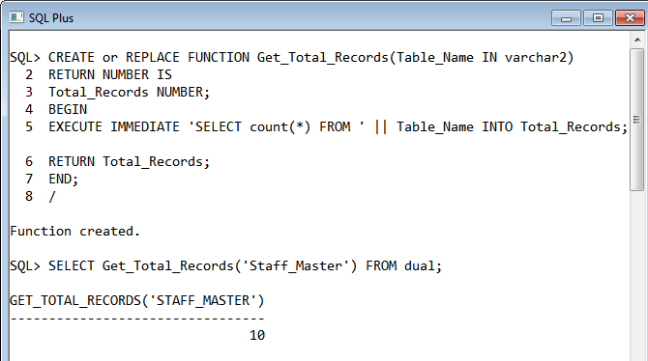

**4.12 Tune the following Oracle Procedure enabling to gain better performance.**

**Objective:The Procedure should update the salary of an employee and at the same time**

**retrieve the employee's name and new salary into PL/SQL variables.**

CREATE OR REPLACE PROCEDURE update_salary (emp_id NUMBER) IS

v_name VARCHAR2(15);

v_newsal NUMBER;

BEGIN

UPDATE emp_copy SET sal = sal * 1.1

WHERE empno = emp_id;

SELECT ename, sal INTO v_name, v_newsal

FROM emp_copy

WHERE empno = emp_id;

DBMS_OUTPUT.PUT_LINE('Emp Name:' || v_name);

DBMS_OUTPUT.PUT_LINE('Ename:' || v_newsal);

END;

**INPUT:**

CREATE OR REPLACE PROCEDURE update_salary (emp_id NUMBER) IS

v_name VARCHAR2(15);

v_newsal NUMBER;

BEGIN

UPDATE emp_copy SET sal = sal * 1.1

WHERE empno = emp_id;

SELECT ename, sal INTO v_name, v_newsal

FROM emp_copy

WHERE empno = emp_id;

DBMS_OUTPUT.PUT_LINE('Emp Name:' || v_name);

DBMS_OUTPUT.PUT_LINE('Ename:' || v_newsal);

EXCEPTION

WHEN NO_DATA_FOUND THEN

DBMS_OUTPUT.PUT_LINE('Employee Does Not Exists');

END;

/

**OUTPUT:**

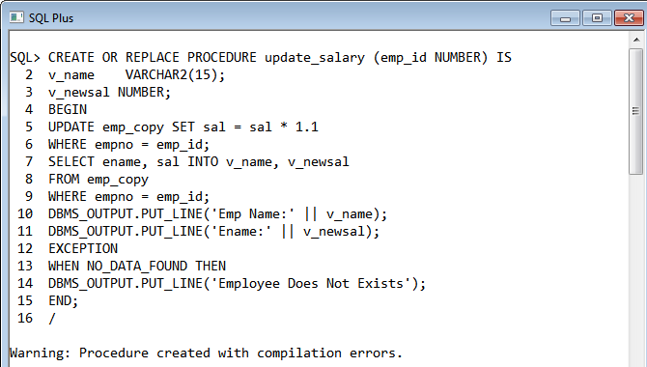

**4.13 The following procedure attempts to delete data from table passed as parameter.This**

**procedure has compilation errors. Identify and correct the problem.**

CREATE or REPLACE PROCEDURE gettable(table_name in varchar2) AS

BEGIN

DELETE FROM table_name;

END;

**INPUT:**

CREATE or REPLACE PROCEDURE gettable(table_name in varchar2) AS

BEGIN

EXECUTE IMMEDIATE 'DELETE FROM ' || table_name;

END;

/

BEGIN

gettable('empl');

END;

/

**OUTPUT:**

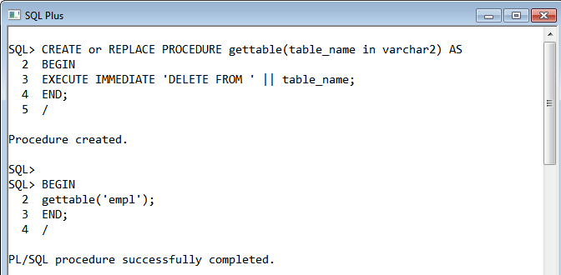

**4.14 Write a procedure which prints the following report using procedure:**

**The procedure should take deptno as user input and appropriately print the emp details.**

**Also display :**

**Number of Employees,Total Salary,Maximum Salary,Average Salary**

Sample output for deptno 10 is shown below:

Employee Name : CLARK

Employee Job : MANAGER

Employee Salary : 2450

Employee Comission :

************************************

Employee Name : KING

Employee Job : PRESIDENT

Employee Salary : 5000

Employee Comission :

************************************

Employee Name : MILLER

Employee Job : CLERK

Employee Salary : 1300

Employee Comission :

************************************

Number of Employees : 3

Total Salary : 8750

Maximum Salary : 5000

Average Salary : 2916.67

------------------------------------

**INPUT:**

CREATE or REPLACE PROCEDURE Combined_Report(Total_Emp IN NUMBER,TOtal_Sal IN NUMBER,Max_Sal IN NUMBER,Avg_Sal IN NUMBER) AS

BEGIN

DBMS_OUTPUT.PUT_LINE('Number of Employees:'||Total_Emp);

DBMS_OUTPUT.PUT_LINE('Total Salary:'||Total_Emp);

DBMS_OUTPUT.PUT_LINE('Maximum Salary:'||Max_Sal);

DBMS_OUTPUT.PUT_LINE('Average Salary:'||TRUNC(Avg_Sal,2));

DBMS_OUTPUT.PUT_LINE('---------------------------');

END;

/

CREATE or REPLACE PROCEDURE Report(Dept_Code in NUMBER) AS

CURSOR Emp_Details IS

SELECT EName,Job,Sal,Comm FROM Emp WHERE DeptNo=Dept_Code;

var Emp_Details%ROWTYPE;

Ecount NUMBER:=0;

Total_Sal NUMBER:=0;

Max_Sal NUMBER:=0;

Avg_Sal NUMBER:=0;

BEGIN

OPEN Emp_Details;

LOOP

FETCH Emp_Details INTO var;

EXIT WHEN Emp_Details%NOTFOUND;

IF Emp_Details%FOUND THEN

Ecount:=Ecount+1;

Total_Sal:=Total_Sal+var.Sal;

IF Max_Sal < var.Sal THEN

Max_Sal:=var.Sal;

END IF;

Avg_Sal:=Total_Sal/Ecount;

DBMS_OUTPUT.PUT_LINE('Employee Name:'||var.EName);

DBMS_OUTPUT.PUT_LINE('Employee Job:'||var.Job);

DBMS_OUTPUT.PUT_LINE('Employee Salary:'||var.Sal);

DBMS_OUTPUT.PUT_LINE('Employee Commission:'||var.Comm);

DBMS_OUTPUT.PUT_LINE('************************************');

END IF;

END LOOP;

CLOSE Emp_Details;

Combined_Report(Ecount,Total_Sal,Max_Sal,Avg_Sal);

END;

/

BEGIN

Report(10);

END;

/

**OUTPUT:**

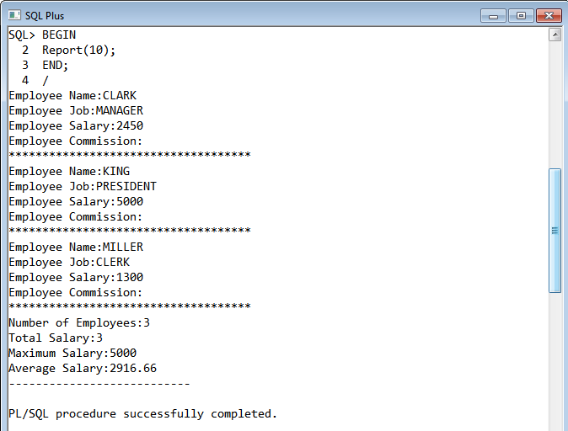

**4.15: Write a query to view the list of all procedures ,functions and packages from the**

**Data Dictionary.**

**INPUT:**

SELECT OBJECT_NAME,OBJECT_TYPE FROM USER_OBJECTS WHERE OBJECT_TYPE IN ('FUNCTION','PROCEDURE','PACKAGE');

**OUTPUT:**

